*Florida International University*

*School of Computing and Information Sciences*

Software Engineering Focus

Feature Document

User Story ID #971

**Name: Send Invitation**

**Team Member: Alvaro Silva**

**Project: SkillCourt 7.0**

**Product Owner(s)**: Guðmundur Traustason

**Mentor(s)**: Masoud Sadjadi

**Instructor**: Dr. Masoud Sadjadi

**Send Invitation:**

* Description: **As a** User **I would like** to be able to send invitations **so that** I challenge other users to play against me.

Acceptance Criteria

* System found the Registration ID after the search
* System is connected can send POST requests

**Use Case**

* Name: Send Invitation
* Actor: System
* Preconditions: Player searched has an account with SkillCourt ***and***

Player has a Registration ID ***and***

App Server is set to send message to FCM Server

* Description <Flow of events>:

|  |  |
| --- | --- |
| Actor Steps | System Steps |
|  | 1. System create a JSON file with the Registration ID. |
|  | 2. System send JSON file to the server by HTTP POST request. |
|  | 3. Server receives the JSON file |
|  | 4. Server decode the JSON file and extracts the Registration ID. |
|  | 5. Server sends message and Registration ID to FCM Server |
|  | 6. FCM Server send message to device with that Registration ID. |
|  | 7. System create a room and add the challenger to it. |

**Use Case Diagram**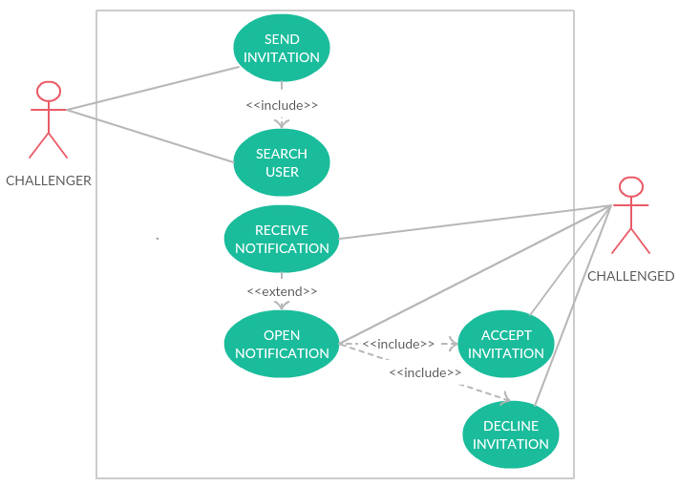

**Sequence Diagram**

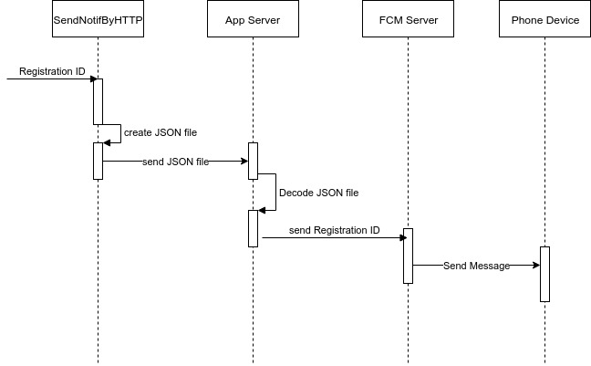

**Unit Test**

* Test case ID:
* Description/Summary of Test: Test if the implementation for sending the notification for multiplayer mode works..
* Pre-condition: SkillCourt app running and app server is deployed.
* Expected Results: Convert the Registration ID in a JSON object, send this to the app server, server to decode, send the Registration ID to FCM Server; create a room and add the challenger to it.
* Actual Result: Converts, decodes, send the Registration ID, creates the room and adds the challenger.
* Status (Fail/Pass): Pass.

**Visual User Guide**

